Session 2025-2026
Mission: To establish learning ambience for ushering in computer engineering professionals in core and
multidisciplinary area by developing Problem-solving skills through emerging technologies.
Vision: To be a well-known centre for pursuing computer
education through innovative pedagogy, value-based education and industry collaboration
Program Educational Objectives of the program (PEO): (broad statements that describe the professional and career accomplishments)
PEO1 | Preparation | P: Preparation | Pep-CL abbreviation pronounce as Pep-si-lL easy to recall
PEO2 | Core Competence | E: Environment (Learning Environment)
PEO3 | Breadth | P: Professionalism
PEO4 | Professionalism | C: Core Competence
PEO5 | Learning Environment | L: Breadth (Learning in diverse areas)

Program Outcomes (PO): (statements that describe what a student should be able to do and know by the end of a program)

Keywords of POs:
Engineering knowledge, Problem analysis, Design/development of solutions, Conduct Investigations of Complex Problems, Engineering Tool Usage, The Engineer and The World, Ethics, Individual and Collaborative Team work, Communication, Project Management and Finance, Life-Long Learning
PSO Keywords: Cutting edge technologies, Research

“I am an engineer, and I know how to apply engineering knowledge to investigate, analyse and design solutions to complex problems using tools for entire world following all ethics in a collaborative way with proper management skills throughout my life.” to contribute to the development of cutting-edge technologies and Research.

Integrity: I will adhere to the Laboratory Code of Conduct and ethics in its entirety.

Name and Signature of Student and Date
(Signature and Date in Handwritten)
Disha Angalwar
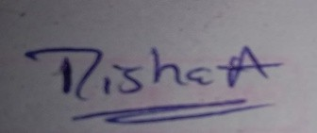

Session | 2025-26 (EVEN) | Course Name | JAVA FSD Lab
Semester | 4 | Course Code | 23ADS1407
Roll No | 4 | Name of Student | Disha Angalwar

Practical Number | 07
Course Outcome | - Analyze Java programs to implement exception handling and file handling operations.  - Design and develop a mini project using Java that integrates object-oriented programming concepts, file handling, and database connectivity.
Aim | WAP to demonstrate exception handling in  java
Problem Definition | Write a program to demonstrate Exception Handling by performing division of two numbers. Handle  the error that occurs when a number is divided by zero using try, catch, and finally.  Steps  1. Create a class named ExceptionDemo.  2. Declare two integer variables.  3. Perform division inside a try block.  4. Handle the error using a catch block.  5. Display a message in the finally block.
Theory  (100 words) | Exception handling in Java is used to manage runtime errors and ensure the normal flow of a program. It uses keywords like try, catch, and finally to handle exceptional situations. In this practical, division of two numbers may cause an ArithmeticException when dividing by zero. The try block contains the risky code, the catch block handles the exception and displays an error message, and the finally block executes regardless of whether an exception occurs or not. This concept improves program reliability, prevents crashes, and ensures proper execution even in error conditions.

Procedure and Execution | Algorithm:  - Start the program.  - Create a class ExceptionDemo.  - Declare two integer variables.  - Take input values for both numbers.  - Use a try block to perform division.  - If division by zero occurs, handle it in catch block.  - Display an error message in case of exception.  - Execute the finally block and display a message.  - Stop the program.
(100 Words)
Code: | import java.util.Scanner;  public class ExceptionDemo {  public static void main(String[] args) {  // Declare variables  int num1, num2, result;  Scanner sc = new Scanner(System.in);  // Taking input  System.out.print("Enter first number: ");  num1 = sc.nextInt();  System.out.print("Enter second number: ");  num2 = sc.nextInt();  try {  // Performing division  result = num1 / num2;  System.out.println("Result: " + result);  }  catch (ArithmeticException e) {  // Handling division by zero  System.out.println("Error: Cannot divide by zero!");  }  finally {  // This block always executes  System.out.println("Finally block executed.");  }  System.out.println("Program continues after exception handling.");  }  }

 | Output:
 | 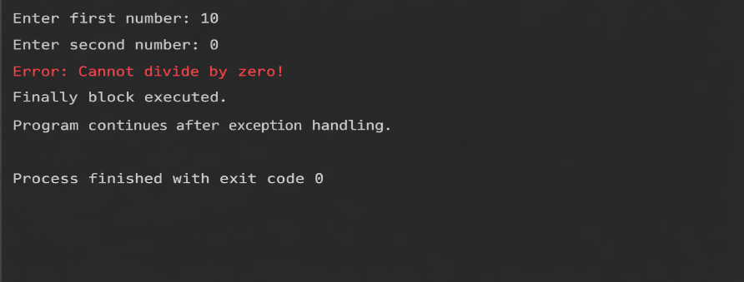
Output Analysis | The program takes two inputs and attempts to perform division.  When the second number is zero, an ArithmeticException occurs.  The catch block successfully handles the error and displays an appropriate message.  The finally block executes regardless of the exception, confirming its purpose.  The program continues execution after handling the exception, showing improved program stability and reliability.

Link of student Github profile where  lab assignment has been uploaded | https://github.com/dishaangalwar84/JavaFSD
Conclusion | This practical demonstrates how exception handling works in Java using try, catch, and finally blocks. It shows that runtime errors like division by zero can be handled gracefully without stopping the program, and the finally block ensures that important code always executes.
Plag Report (Similarity index < 12%) | 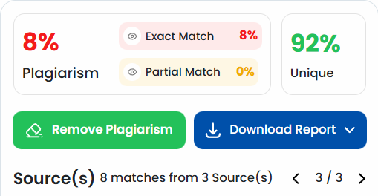
Date | 24 Mar 2026
Faculty signed observation page.

